Design Document

**Digital Board Marker**

Marker Hardware Description

This module is designed and developed by   
Hamza Farooq (2016-CS-122)  
  
Supervised by  
Samyan Qayum Wahla

Date: Aug 8, 2019

Table of Contents

1. Document Purpose 6

2. Requirements Addressed 6

3. Detailed Design 6

3.1. Transmitter 6

3.1.1. Short Description 6

3.1.2. Component Diagram 6

3.1.3. Schematic Diagram 10

3.1.4. Component Connection Diagram 11

3.2. Receiver 12

3.2.1. Short Description 12

3.2.2. Schematic Diagram 12

3.2.3. Component Connection Diagram 13

4. Rules and Assumptions 14

5. Module Workflow Description 14

3.1. General Flow 14

3.1.1. General Flow Diagram 15

6. Tools and languages used 15

6.1. Arduino IDE v1.8.9 15

6.2. Processing v3.5.3 15

7. References 16

List of Figures

Figure 1 - Component Detail 7

Figure 2 - Tact Tactile Switch 8

Figure 3 - DC-DC Boost Converter 8

Figure 4 - Glowing Ball 8

Figure 5 - Arduino nano 8

Figure 6 - Lipo Battery 8

Figure 7 - RGB Led 9

Figure 8 - MPU-6050 9

Figure 9 - nRF24L01 9

Figure 10 – Schematic Diagram Transmitter 10

Figure 11 - Component Connection Transmitter 11

Figure 12 - Schematic Diagram Receiver 12

Figure 13 - Component Connection Receiver 13

Figure 14 - MPU-6050 Marker Alignment Description 14

Figure 15 - Transmitter Alignment Description 14

Figure 16 - Transmitter General Workflow 15

Figure 17 - Receiver General Workflow 15

Figure 18 - Teapot Image in Processing 16

List of Tables

Table 1 - Revision History 5

Table 2 - Requirements Addressed 6

Table 3 - Transmitter Components Detail 9

**Revision History**

|  |  |  |  |
| --- | --- | --- | --- |
| **Author** | **Date** | **Version** | **Notes** |
| Hamza Farooq | Aug 8, 2019 | v1.0 | Document of first stable version of module |
|  |  |  |  |
|  |  |  |  |
|  |  |  |  |

Table 1 - Revision History

# Document Purpose

This document addresses all functionalities, Structure, Workflow and detailed overview of board marker hardware prototype. It describes requirements, design diagrams and structure diagrams, programming tools and languages used in designing and developing the hardware module.

# Requirements Addressed

|  |  |  |
| --- | --- | --- |
| **#** | **Requirement** | **Priority** |
|  |  |  |
| **1** | Determine orientation of board marker and calculate respective Euler angles | HIGH |
| **2** | Transmit the calculated Euler angles to desktop app via nrf24l01 module | HIGH |
| **3** | Transmit the calculated Euler angles to desktop app via RS232 serial connection | LOW |
| **4** | Turn on using 3.6 volts Lipo battery with Boost converter circuit | MEDIUM |
| **5** | Build battery charging circuit within board marker | LOW |
| **6** | Implement RGB Led for positioning purpose (Input for camera module) | HIGH |

Table 2 - Requirements Addressed

# Detailed Design

Marker hardware has two major sub-modules named as **Transmitter** (marker itself)and **Receiver**

## Transmitter

## Short Description

The objective of the transmitter module is to extract orientation of the board marker. The challenge is the marker is changing its orientation while writing on the board. Transmitter module is designed as a back cap of board marker. It is attached to the board marker to record orientation of marker.

## Component Diagram

Diagram of transmitter module with functioning components highlighted with numbered squares is given below

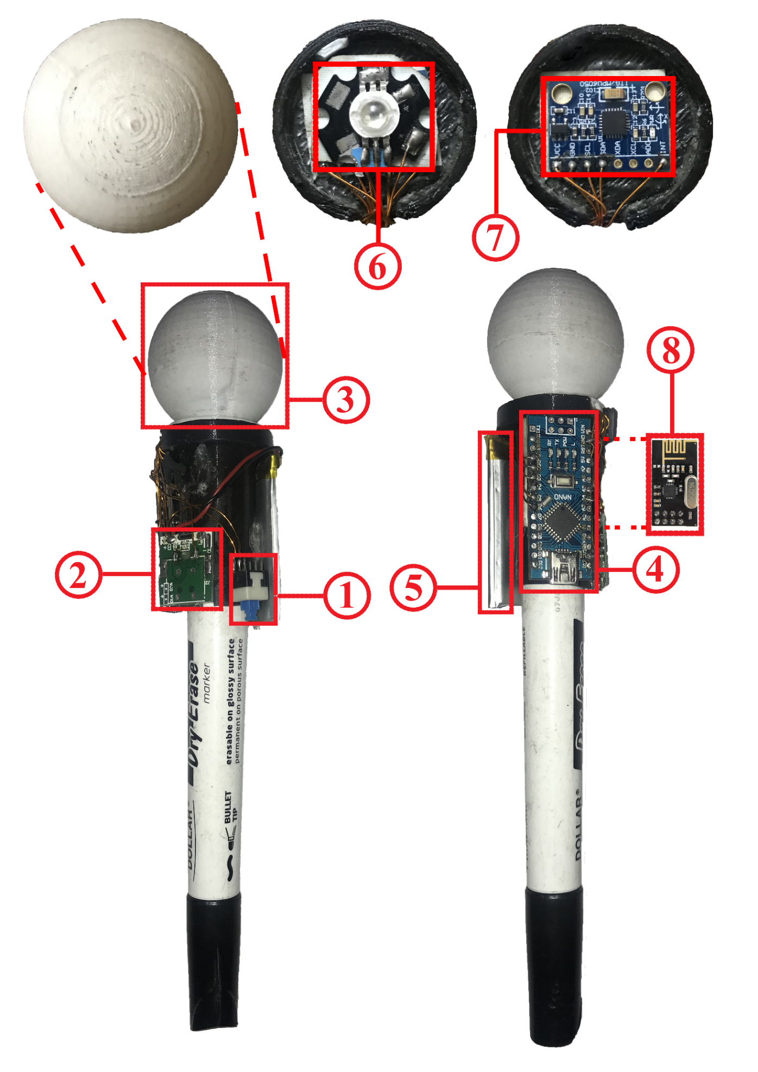

Figure 1 - Component Detail

|  |  |  |
| --- | --- | --- |
| **Component Number** | **Description** | **Diagram** |
|  |  |  |
| **1** | **Name:** Tact Tactile Switch | Figure 2 - Tact Tactile Switch |
| **Detail:** Toggle switch that turns on/off the system when runs on Battery. It does not have any effect when system is running via USB cable. |
| **2** | **Name:** USB DC-DC Boost Converter | Figure 3 - DC-DC Boost Converter |
| **Detail:** Converts the 3.7V to 5V to turn on and constantly run the Arduino nano prototype board. This sub-module has built-in charging circuit that charges the battery through USB connection. |
| **3** | **Name:** Glowing ball | Figure 4 - Glowing Ball |
| **Detail:** Round shaped glowing ball can glow in any combination of RGB colors. It is not for just looks but acts as an input to Stereo cameras for position tracking. |
| **4** | **Name:** Arduino nano | Figure 5 - Arduino nano |
| **Detail:** Arduino nano acts as main processing board to which all modules and sensors are attached. It acts just like a motherboard with central processor chip soldered on mainboard. |
| **5** | **Name:** Lipo battery | Figure 6 - Lipo Battery |
| **Detail:** 600mAh 3.7V Lipo battery used to run system while there is no USB connection. Voltage may be up to 4.2 volts when fully charged.  DC-DC Boost Converter is hooked up with the battery that charges the battery as well as raises its voltage to 5V to make the Board Marker Transmitter working properly. |
| **6** | **Name:** dc-le14112 RGB Led | Figure 7 - RGB Led |
| **Detail:** 3W RGB Led used to create custom color of choice, the corresponding color that is required for position sensing can glow in Glowing ball. It may be given external power source but, in our case, it is directly connected to Arduino nano. |
| **7** | **Name:** MPU-6050 | Figure 8 - MPU-6050 |
| **Detail:** MPU-6050 or GY-521 board contains accelerometer and gyroscope packed in a single chip. It senses the orientation of the object. It is connected to Arduino nano via I2C bus. |
| **8** | **Name:** nRF24L01 | Figure 9 - nRF24L01 |
| **Detail:** nRF24L01 is a single chip radio transceiver. It is responsible for transmitting orientation data from transmitter module to receiver. |

Table 3 - Transmitter Components Detail

## Schematic Diagram

Circuit diagram of Transmitter module is represented as below

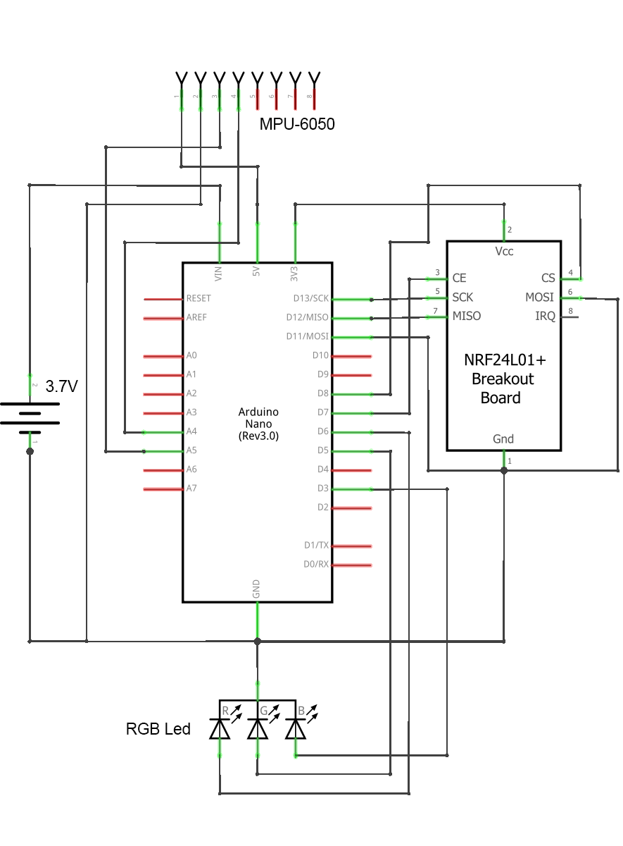

Figure 10 – Schematic Diagram Transmitter

## Component Connection Diagram

This diagram represents how sub-modules or components are connected in Transmitter module.

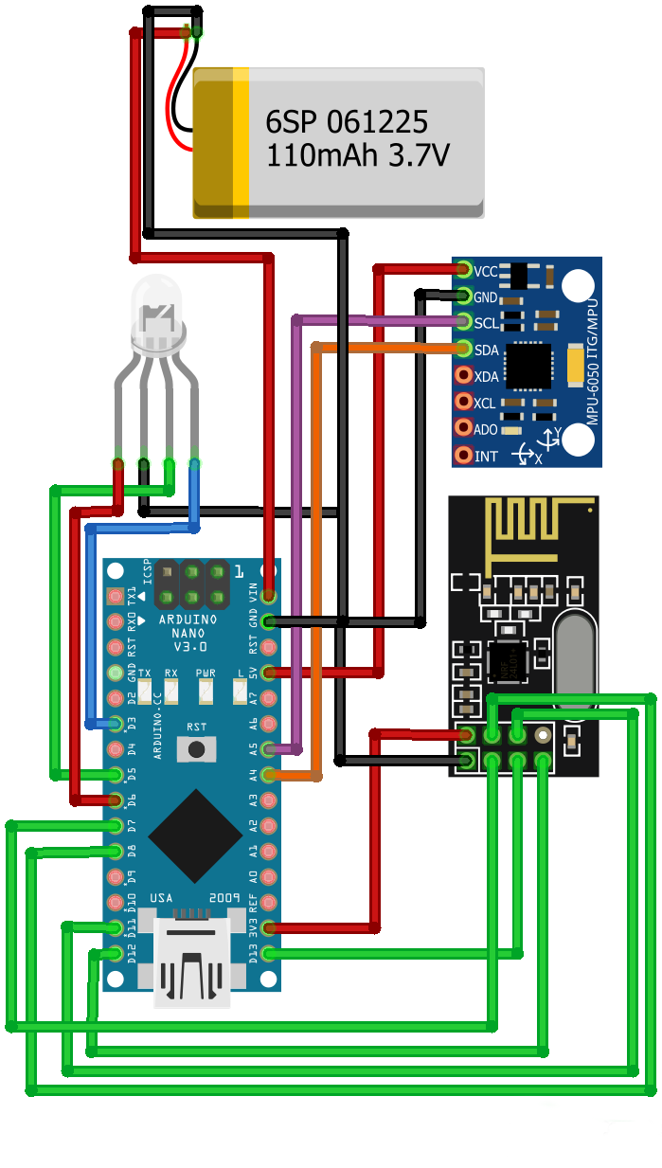

Figure 11 - Component Connection Transmitter

## Receiver

## Short Description

Receiver module receives orientation data as Euler angles and transfer it to the desktop application via USB connection. As it is connected via USB so it does not need any external power source.

## Schematic Diagram

Schematic diagram that shows abstract component view of Receiver module is given below

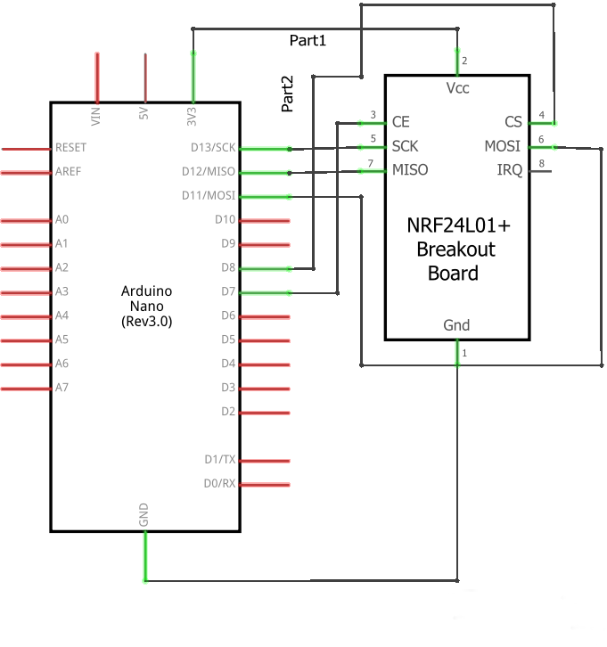

Figure 12 - Schematic Diagram Receiver

## Component Connection Diagram

This diagram represents how sub-modules or components are connected in Receiver module.

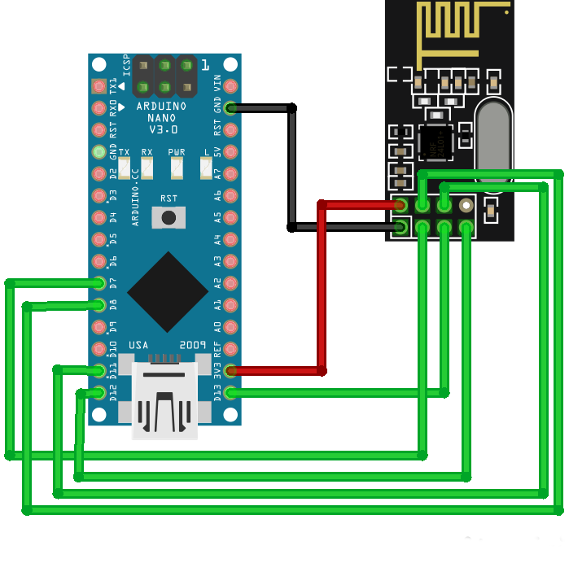

Figure 13 - Component Connection Receiver

# Rules and Assumptions

Following are rules and cases of assumptions that are assumed to be true while normal working

* Board Marker Transmitter and Receiver are in range of 2 meters for less noise and preventing latency issues.
* Lipo Battery is assumed to give 5 volts to Arduino nano mainboard. For this purpose, a dc-dc boost converter is hooked up with the battery to achieve continuous 5V output.
* Board Marker Transmitter has at least 30% of battery remaining so that boost converter can easily deliver 5V output.
* Power Switch of Board Marker Transmitter is assumed to be turned on while in working mode.
* Power Switch of Board Marker Transmitter is assumed to be turned off while in debugging USB connection mode.
* In order to calculate the orientation of marker correctly, following alignment of the marker is assumed in which Board Marker Transmitter is aligned in the negative Z direction.

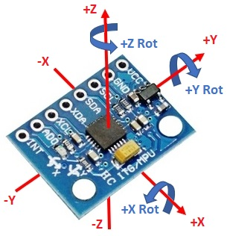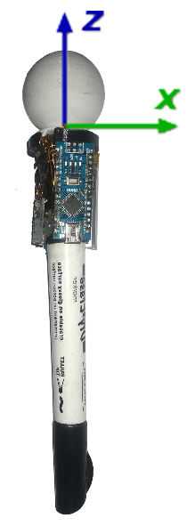

Figure 14 - MPU-6050 Marker Alignment Description

Figure 15 - Transmitter Alignment Description

* Appropriate RS232 serial connection drivers are installed on the desktop with which Receiver module is connected.

# Module Workflow Description

Board marker module hardware consists of **Board Marker** or the transmitter and **Receiver**.

## General Flow

* **Board Marker** trytoestablish wireless connection with the receiver. RGB Led fades meanwhile.
* RGB Led turns to constant red after successful connection.
* Accelerometer unit in the **Board Marker** determines the orientation data.
* NRF24l01 wireless module in the **Board Marker** transmits the orientation data to **Receiver** wirelessly.
* **Receiver** Transfers orientation data to desktop app via serial connection

## General Flow Diagram

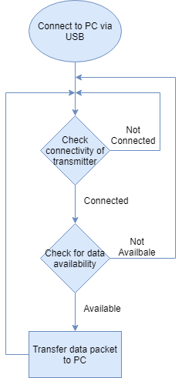

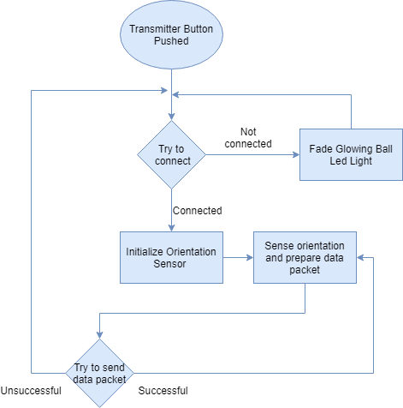

Figure 16 - Transmitter General Workflow

Figure 17 - Receiver General Workflow

# Tools and languages used

List all software that are used to develop and needed to operate the developed module are detailed below.

## Arduino IDE v1.8.9

Code environment in which all code for Board Maker Transmitter and Receiver is written. This IDE is numerously used as a debugging tool as well.

## Processing v3.5.3

This tool is used for debugging and visualization of Board Marker Transmitter as a teapot object. In order to view Board Marker Transmitter and verify the placement of MPU-6050 orientation sensor and latency, we visualized the teapot object moving in the window of Processing software. Following parameters and properties are visualized and debugged.

* Correct orientation data packet format of Board Marker Transmitter.
* Generation of noise with respect to obstacles and distance involved while data transmission.
* Latency in data transmission with respect to obstacles and distance involved while data transmission.

Sample image of object is given below

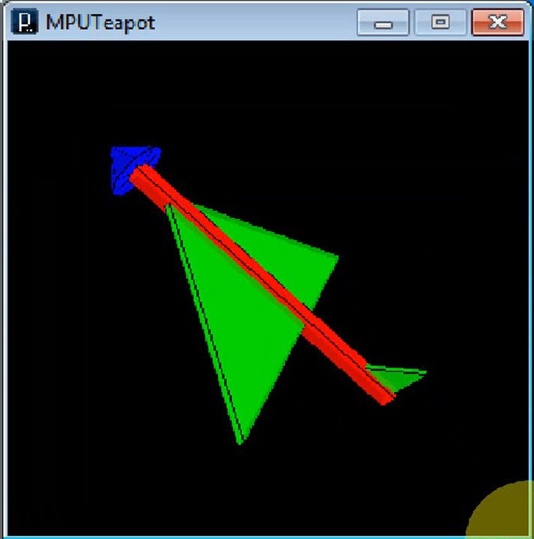

Figure 18 - Teapot Image in Processing

# References

List all documents that were used in defining the design documented in this document.